Technical Solution Offer Description for Vinaphone

Based on Comverse® ONE™ Real-Time Billing

ComverseOne_type[1]

Copyright and Trademarks

Copyright © 2010 Comverse, Inc. All rights reserved.

Comverse, its logo, the spark design, Kenan and Netcentrex are registered trademarks of Comverse Technology, Inc. or its subsidiaries in the United States and other selected countries. Other denoted product names of Comverse or other companies may be trademarks or registered trademarks of Comverse, Inc. or its subsidiaries, or their respective owners.

Table of Contents

[Introduction 4](#_Toc357415988)

[Document References 6](#_Toc357415989)

[Solution 7](#_Toc357415990)

[Solution Architecture for VNP 10](#_Toc357415991)

[Comverse](#_Toc357415992)[®](#_Toc357415992) [ONE™ Real-Time Billing Components 11](#_Toc357415992)

[Assumptions 13](#_Toc357415993)

[General Assumptions 13](#_Toc357415994)

[Integration Assumptions 15](#_Toc357415995)

[Migration Assumptions 16](#_Toc357415996)

[Project scope Assumptions 16](#_Toc357415997)

[End-to-End scenario Assumptions 17](#_Toc357415998)

[Integration Points and Description 21](#_Toc357415999)

[Integration Points 21](#_Toc357416000)

[Technical Architecture 25](#_Toc357416001)

[Production system 25](#_Toc357416002)

[Technical Architecture Components 26](#_Toc357416003)

[Online Components 26](#_Toc357416004)

[Hardware Scalability and High Availability 28](#_Toc357416005)

[About Comverse 31](#_Toc357416006)

# Introduction

Comverse is pleased to offer Comverse® ONE™ Real-Time Billing, to meet the Vinaphone (VNP) requirements for a real time postpaid rating and charging solution, and real time prepaid rating and charging solution.

Based on our knowledge of VNP project objective, Comverse is pleased to suggest the deployment of the Comverse® ONE™ Real-Time Billing (Comverse ONE RT) to address VNP’s mid-term and long-term goal. Comverse ONE RT combines the best-of-breed capabilities of the RTBS prepaid IN system. Comverse ONE provides a unified rating engine, a common product catalog, single set of APIs, well-meshed balance management concepts, etc.

With Comverse ONE RT, VNP can:

* Evaluate the upgrade path from existing RTBS to the Comverse ONE for prepaid subscribers
* Comverse ONE software capable to run on the existing hardware which currently serve the RTBS for example IBM P6 SDP, DPM3
* Create and launch new promotions and offers to their market quickly. With the new user-friendly GUI Product Catalog, CAT can easily configure these offerings independently. The new GUI include advance capability such as reusable object, drag and drop, graphical view of product configuration
* Support real time rating, charging, and promotion with credit limit for postpaid subscribers
* Support near real time offline rating, charging, and promotion with credit for postpaid subscribers
* Support real time rating, charging, and promotion for prepaid subscribers
* Provide the platform for VNP to evaluate the new business modeling such as hybrid
* Provide the platform for VNP to evaluate full capability of service convergence
* Provide the platform for VNP to evaluate full capability of charging convergence
* Provide same features, promotion, and rating for prepaid, postpaid and hybrid subscribers
* Provide SARBOX (SOX2000) security capability in order for VNP to have much secure Rating, Charging and Promotion platform
* All the VNP specific customizations will be supported on Comverse ONE RT and will applicable to use for both prepaid and postpaid subscribers
* Fully support its vision of unification and operational efficiency, with its support for open interfaces that expose Comverse ONE’s capabilities externally.
* Comverse ONE platform has capability to access to centralize voucher server of VNP
* Comverse ONE provides network integration compatibilities as same as RTBS. Which means all of the integrations that have done on RTBS today will be fully supported by Comverse ONE. For example CAMEL phase 2 (Voice/Video), CAMEL phase 3 (SMS), Diameter PS for GGSN data charging, Payment Server Interface (or Even Charging Interface) and others.
* Provide the platform for VNP to evaluate and decide if VNP will want to upgrade for the fully integrate Convergence solution in the future

Comverse suggests that a phased approach be adopted in implementing the Comverse ONE RT. The main focus at the beginning shall be Real time postpaid subscribers, and follow by real time prepaid subscribers, and then hybrid subscribers accordingly. The system implementation will be done at one time but the configuration to support prepaid subscribers and hybrid subscribers can be done at later stage.

# Document References

The Comverse ONE product is the basis for the solution being proposed. A complete description of the product capabilities can be found in the following document, which is being supplied as a part of this proposal:

*Comverse® ONE™ Real-Time Billing Solution Description*

# Solution

The current VNP’s BSS include of the following components.

* Comverse RTBS platform as an OCS for real time rating, charging, and promotion for all prepaid subscribers
* VNP in house development rating, charging and promotion system for postpaid subscribers
* VNP in house BSS which provide the BSS support functionalities such as Provisioning, Postpaid functions (re-rating, adjustment, and time based promotion), customer care system for prepaid, and self care system for prepaid
* For mobile prepaid subscribers, VNP own the customer and provide end-to-end services to prepaid customer
* For mobile postpaid subscribers, VNP will provide end to end services including invoicing, contract management . P&T support human resource for collection, customer care etc.

The following diagram shows the high level BSS map of VNP

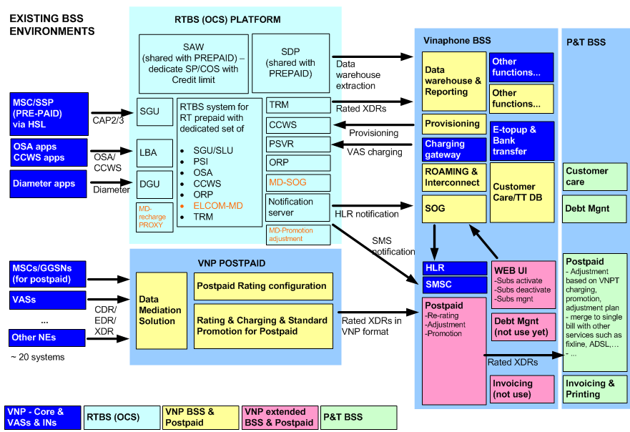

Figure – Existing VNP’s BSS map

The current VNP’s RTBS infrastructure consists of a number of systems and applications. Currently, the system is capable to support up to 53.5M subscriber licenses. The diagram below shows the current overall VNP’s RTBS and its integrations

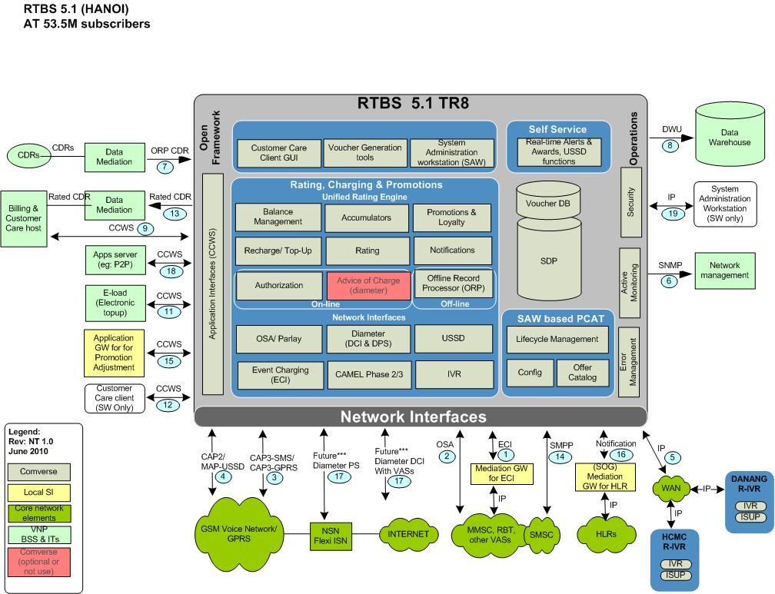

Figure – Existing VNP’s RTBS Architecture

In order to meet the full set of requirements of VNP, Comverse proposes a solution consisting of Comverse® ONE™ Real-Time Billing. The following approached is proposed.

* Implement the Comverse ONE RT as OCS real time rating/charging/promotion of voice/data/transaction for mobile postpaid subscribers. The Comverse ONE RT will integrate to core network via the CAMEL/ISUP/MAP Signaling and Diameter interface.
* Integrate the Comverse ONE RT to the existing BSS infrastructure
* The following step can be done with PCAT configuration
  + Extend the Comverse ONE RT as OCS real time rating/charging/promotion of voice/data/transaction for prepaid subscribers (segment of prepaid subscriber up to 500K). It will provide VNP the platform for verify & test the feature backward compatibility with RTBS. Then VNP can have long term plan for upgrade path from RTBS to Comverse ONE.
  + Extend the Comverse ONE RT to support new business modeling such as hybrid

The following diagram shows the VNP BSS map after the implementation

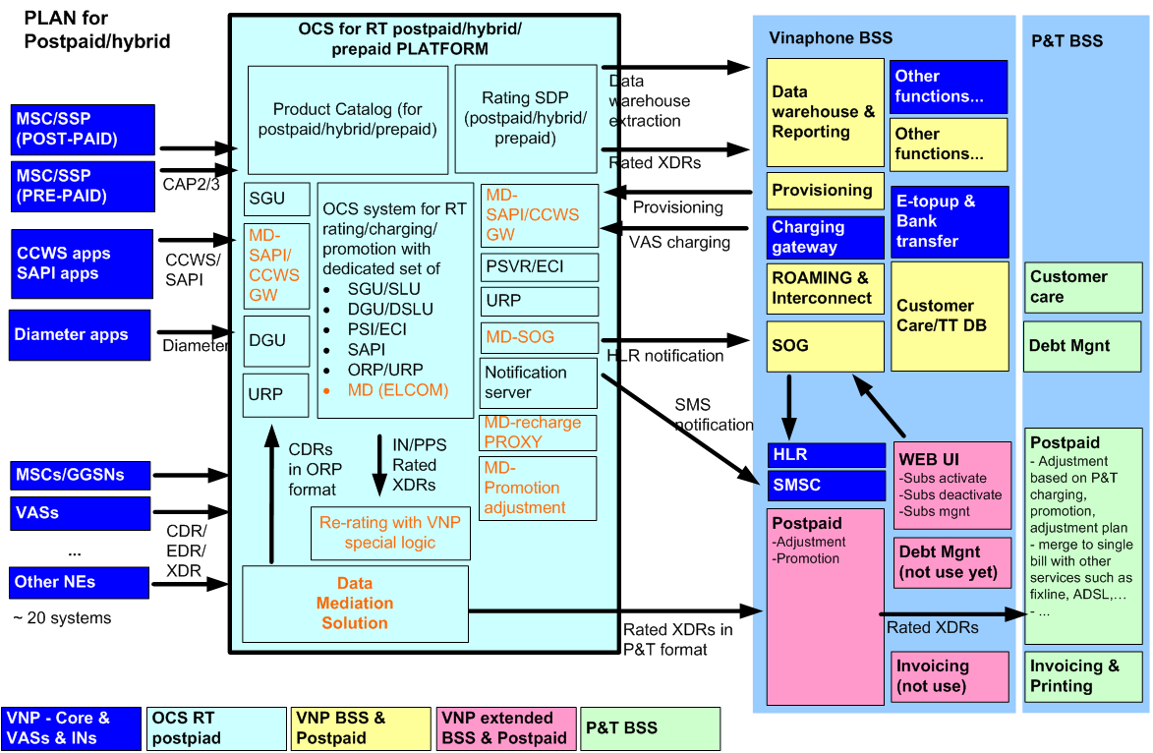

Figure – VNP’s BSS map after implementation

Then after the implementation of Comverse ONE RT, VNP can evaluate the upgrade path from RTBS to Comverse ONE RT. Once this plan is validated and agreed for both sides then the proper project can be prepared. Comverse will provide the upgrade proposal with detail SOW at the later stage.

## Solution Architecture for VNP

The proposed solution architecture and its relation to the VNP network and enterprise environment are shown below. The propose solution will mainly serve the real time mobile postpaid subscribers, segment of mobile prepaid subscribers, and hybrid customer. The system will be side-by-side with existing RTBS platform but have access to the VNP centralize vouchers.

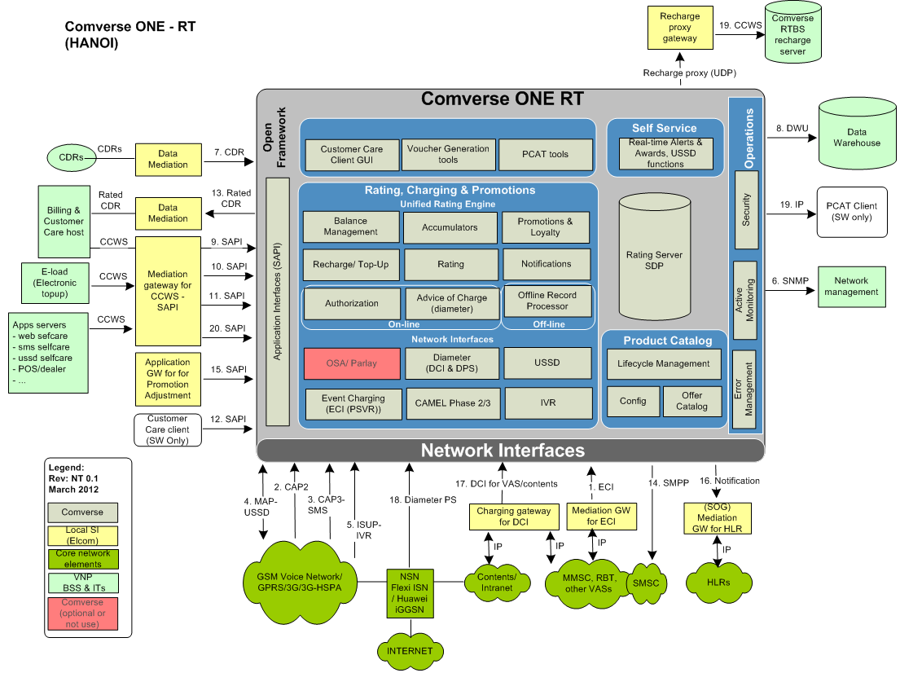

Figure – Solution Architecture

In the above solution architecture, the light grey components are Comverse components included in the scope of this proposal.

* The red items are Comverse components that are not included in the scope of this bid.
* The components in yellow and orange in the above figure are ELCOM BSS elements and applications to which the Comverse Solution will integrate through various interfaces described in the table integration points and description section.
* The components in green (dark and light) in the above figure are VNP network/VAS elements and applications to which the Comverse Solution will integrate through various interfaces described in the table integration points and description section.

The proposed Comverse ONE RT will be set up and deployed for launch readiness. Targeted groups of customers will be mobile postpaid subscribers, and segment of mobile prepaid for compatibility test.

## Comverse® ONE™ Real-Time Billing Components

The following table summarizes the Comverse ONE licensed components that are available and identifies those that are included in this proposal:

| **Comverse ONE Domain** | **Comverse ONE Licensed Product** | **Included (Yes/No)** |
| --- | --- | --- |
| Rating, Charging and Promotions | Rating Charging and Promotions | Yes |
| Rating, Charging and Promotions | IVR Self Service | Yes |
| Rating, Charging and Promotions | USSD Self Service | Yes |
| Rating, Charging and Promotions | Calling Circles | Yes |
| Rating, Charging and Promotions | Event Charging Interface | Yes |
| Rating, Charging and Promotions | OSA/Parlay Charging Interface | No |
| Rating, Charging and Promotions | Diameter Charging Interface | Yes |
| Rating, Charging and Promotions | Packet Switched Diameter Charging Interface | Yes |
| Rating, Charging and Promotions | IMS Diameter Charging Interface | No |
| Charging and Promotions | SIP | No |
| Rating, Charging and Promotions | CAMEL 3 SMS | * + - * 1. Yes |
| Rating, Charging and Promotions | CAMEL 3 GPRS | No |
| Rating, Charging and Promotions | USSD Callback | No |
| Rating, Charging and Promotions | IN Signaling Interface: WIN(IS826) | No |
| Rating, Charging and Promotions | IN Signaling Interface: ISUP | Yes |
| Rating, Charging and Promotions | IN Signaling Interface: CAMEL 2(Voice) | Yes |
| Rating, Charging and Promotions | IN Signaling Interface: ETSI(INAP) | No |
| Rating, Charging and Promotions | IN Signaling Interface: Nortel IS-41P | No |
| Rating, Charging and Promotions | Electronic Recharge – eTopUp | No |
| Rating, Charging and Promotions | Electronic Recharge – Peer-to-peer | No |
| Rating, Charging and Promotions | Electronic Recharge – mAgent | No |

The following table summarizes the Comverse ONE functional components where professional services to support installation, configuration, and integration are included in this proposal:

| Comverse ONE Functionality | Included in Bid (Yes/No/Optional) |
| --- | --- |
| Product Catalog Lifecycle Management | Yes |
| Product Catalog Offer Catalog | Yes |
| Balance Management | Yes |
| Accumulators | Yes |
| Promotions & Loyalty | Yes |
| Recharge/ Top-up | Yes |
| Rating & Guiding | Yes |
| Notifications | Yes |
| Authorization | Yes |
| File Processing | Yes |
| OSA/ Parlay | No |
| IVR | Yes |
| ECI | Yes |
| Diameter | Yes |
| SIP | No |
| IN (CAP2(VOICE), CAP3 (SMS), MAP(USSD) | Yes |
| USSD Recharge, Info Server | Yes |
| USSD Callback | No |
| Customer Care Client | Yes |

Specific information about the professional services provided to support the above items can be found in the services portion of the Comverse proposal.

# Assumptions

In developing the proposed solution for VNP, Comverse has had to make certain assumptions about VNP’s environment and about responsibilities for various activities regarding the delivery of the solution. Changes to the below assumptions may require Comverse to change the proposed solution and result in additional fees to VNP.

The following assumptions have been made with respect to the proposed solution:

## General Assumptions

1. The solution that Comverse provides will have a centrally managed product catalog where offer information is defined and maintained. Information from the central product catalog will be synchronized / propagated to all Comverse ONE RT for rating and charging purposes. This solution does not include being able to synchronize the Comverse centralized product catalog information with non Comverse ONE RT. Subscribers requiring new plans in the Comverse system can be migrated.
2. There is migration of subscribers from existing postpaid system. There is no migration on transaction history, . Comverse will provide only migration support. Comverse will provide the recommendation on expect input migration format. Then ELCOM/VNP will need to prepare the data into Comverse expect format eg: ccbatch. Then Comverse will provide support on execute of this migrated data. Comverse does not handle data cleansing, or data crunching. The mobile postpaid configuration must be configured via the product catalog.
3. The integration between Comverse ONE RT and VNP BSS are done through U-API and batch. The ELCOM/VNP will handle these integrations around Comverse ONE RT
4. Comverse recommends the
   1. Comverse Diameter Charging Interface (DCI) for VAS integration
   2. Comverse Diameter Packet Service (DPS) for GGSN integration
5. Comverse supports the following 3GPP standards with the following exceptions:
   1. TS 32.240 Charging Architecture and Principles
   2. TS 32.250/251 CS/PS Domain
   3. TS 32.270/272 SMS/MMS
   4. TS 32.296 Online Charging System (Reference points Ro, Rc, Ga, Re supported)
      1. TS 32.296 define the internal functional blocks of an OCS and define various interfaces among these functional blocks. Comverse ONE logically provides similar functions to the OCS breakdown in TS32.296 (e.g. OCF, ABMF, Rating Function, etc.), however the interaction among these elements is entirely internal to Comverse ONE
   5. TS 32.299 Diameter Charging Application
      1. The 3GPP Ro interface is based on RFC 4006.  It adds support for many 3GPP services (IMS, Packet Switched, SMS, MMS, etc.).   Comverse supports all the messages (CCR/CCA) and business models (centralized and decentralized unit and rate determination; event & session charging) specified in the standard.  However, since 3GPP defined 32.299 as the main Diameter standard and then separate middle tier specifications for each service (e.g. TS 32.251 for Packet Switched, TS 32.260 for IMS, etc.), the compliance to 32.299 should not automatically mean that all the middle-tier standards are also supported. Comverse support middle-tier standards for IMS and Packet Switched services
      2. The full capability of 32.299 Diameter Charging Application can be found in the “Charging Interfaces Guide” manual which will be supplied during project delivery.
   6. RFC 4006 Diameter based interface
      1. Comverse ONE supports RFC 4006 based credit control and supports all the standard messages (CCR/CCA; RAR/RAA).  Both Event & Session Charging models are supported. The full capability RFC 4006 based Diameter Charging interface can be found in the “Charging Interfaces Guide” manual which will be supplied during project delivery.
   7. RFC 3588 Diameter based interface
      1. Comverse ONE supports RFC 3588 based peer connections.  Comverse ONE supports TCP and SCTP based transport.  For Security, only IPSec is supported at this time
6. Please see Comverse Camel 2 Compliance documents for full details of Comverse CAMEL 2 compliancy. Integration to network for CAMEL 2/3 signaling will either be direct to the MSC over HSL/Signtran.
7. Real Time VAS/content charging to VAS/content platforms is also assumed to be via Comverse Diameter Charging Interface and Payment Server Interface (Event Charging Interface) and simulation CAP2. We assume that VAS’s providers will adapt to CAP2 simulation.
8. Offline charging which is performed in offline mode by using CDR’s from external system. CDR’s from external system must be in Comverse format.
9. Comverse IVR is included to provide pre call announcements and IVR self-care.
10. At least two currencies are included in the scope of this solution.
11. VNP’s CSR can use the Customer Care Client for basic subscriber management capabilities including:

* Create and manage accounts and subscribers
* Manage account offers
* Manage subscriber bundles
* Manage subscriber offers
* Manage subscriber supplementary offers
* Recharge the owning account balance
* Recharge a subscriber balance
* Provide support for shadow subscribers and limited liability redirection for subscribers
* Manage subscriber balances including shadow balances
* Manage account balances including target balances for subscriber shadow balances
* Manage vouchers

## Integration Assumptions

1. In case, DWH extracts need to be distributed to multiple systems and in a different format, ELCOM/VNP will responsible for distribution and conversion of the data to the multiple sources that require DWH extract inputs
2. Customer will use DWH extracts as a source of information for their own Reporting Application. DWH extracts would be in a format supported by Comverse ONE and external applications should use it as is for further analysis, reporting or additional data transformation on their side
3. A number of VNP applications, such as top-up gateway, provisioning gateway, self-care, will be upgraded to be able to integrate with Comverse ONE RT via the Comverse U-API (SAPI) interface. The SAPI supports for Java and web-services. The Comverse ONE provides specific API library for electronic top-up. The Comverse consultant will recommend VNP/ELCOM the proper API message. Comverse includes SME support for SAPI limited to 6 man months.
4. Comverse will integrate the Comverse ONE RT with the VNP core network as states in the solution diagram. The online integration points are OOTB which includes CAP2, CAP3, MAP-USSD, ISUP-IVR, Diameter PS, Diameter CI, SMPP, ECI and SAPI. The offline integration points are OOTB which includes File based exchange for rated CDR, DWH extraction, offline CDRs. The system also include SNMP for NMC integration
5. Integrations performed to Comverse ONE via Unified API will be performed using the product defined Unified API methods.
6. Customer Care Client is provided out of the box. Project Technical Assumptions
7. The Implementation Planning Analysis (IPA) output will be technical specification documents, which must be closed, agreed and signed by all parties (VNP, ELCOM and Comverse)
8. VNP/ELCOM will be responsible for reviewing and providing feedback, and approval (when appropriate), of the documents submitted by Comverse
9. VNP/ELCOM will assign a Project Manager with delegated authority to make decisions on behalf of VNP/ELCOM, for the project duration. They will be responsible for the project on VNP/ELCOM side and be the main point of contact for Comverse Project Managers/Directors
10. VNP/ELCOM will provide a project office with the necessary infrastructure. The project office consists of facilities to accommodate the project team. This includes (but not is limited to):

* Facilities with proper access control and security
* Access to the development and testing environments
* Access to the production environment
* Communication and network facilities, to enable the team to work unrestricted by inadequate response times, including without limitation: Internet connection, facsimile, telephone with international dialing facilities, power and printing, photocopier
* Other office logistics, such as paper, whiteboards, drinking water, air conditioning

1. VNP/ELCOM will be responsible for co-ordinate the interfaced network elements and providing test environment from these systems including in the tests phases of the project
2. VNP/ELCOM will grant reading access to the production data (needed for testing purposes).
3. Comverse will assume that VNP/ELCOM project management team will act as overall coordination for the entire project, and take full responsibility for any third parties that are involved, i.e. VNP/ELCOM manages at the program level, Comverse manages its own deliverables
4. Comverse assumes that a mutually agree project plan will be confirmed, with appropriate Role and Responsibility identified between all parties
5. End to End testing (from network to Rating) is under VNP/ELCOM responsibility. Comverse responsible only until the delivery of system test. Integration test support from Comverse is limited to the duration given in the project plan. Comverse will need to rely on VNP/ELCOM for cooperation with the network vendors.

## Migration Assumptions

1. There is migration of subscribers from existing postpaid system. There is no migration on transaction history. Comverse will provide only migration support. Comverse will provide the recommendation on expect input migration format. Then ELCOM/VNP will need to prepare the data into Comverse expect format eg: ccbatch. Then Comverse will provide support on execute of this migrated data. Comverse does not handle data cleansing, or data crunching. The mobile postpaid configuration must be configured via the product catalog.
2. The solution that Comverse provides will have a centrally managed product catalog where offer information is defined and maintained. The Comverse ONE Product Catalog will only manage offers for the Comverse ONE system;

## Project scope Assumptions

Below are high level project scopes between Comverse and Elcom/VNP.

1. Comverse Scope

* Responsible to deliver C1-RT with integration to core network and C1-RT system readiness for Real Time rating/charging/promotion
* OOTB Comverse ONE RT solution for VNP. The standard CAP2, CAP3, MAP-USSD, ISUP-IVR, ECI, Diameter CI, and Diameter PS are included in the project
* Lead and fully support PCAT configuration & testing for ATP and migration. .
* External BSS from Elcom/VNP will also integrate with C1RT via API as well as collect rated CDR for adjusting, billing, invoicing etc. Comverse experts support Elcom/VNP on the logic of integration between external BSS and C1RT, the logic of adjustment to meet requirements of Elcom/VNP
* Provide SAPI and SME support for SAPI is limited to 6 Man months and additional has to be on T&M
* Ported VNP’s RTBS customized features to C1-RT
* CCC will be provided as backup tool for customer care

1. Non Comverse Scope

* The end-to-end integration of C1-RT with GPC’s BSS will be Elcom’s responsibility
* Elcom will responsible to process the rated CDR of C1-RT and update to existing BSS
* Elcom will responsible to process the DWH extraction of C1-RT and update to existing BSS
* Postpaid subscriber profile migration data extraction & cleansing will be done by ELCOM and data will be provided in Comverse format (CCbatch). Comverse responsible for execute CCbatch. The transaction histories are not included in scope of migration.
* Elcom will responsible for integration to existing Comverse RTBS voucher server via the recharge proxy

## End-to-End scenario Assumptions

1. There are several end-to-end scenarios related to mobile postpaid. These scenarios will need to highlight clearly in order for VNP/ELCOM to understand the work impact on the existing BSS which is VNP’s in house development. They are shown below
   1. New plan creation

ELCOM/VNP will need to create the mobile postpaid product configuration in Comverse ONE RT’s product catalog. Comverse will provide product catalog configuration tool. The product configuration in the product catalog will contains several step as below

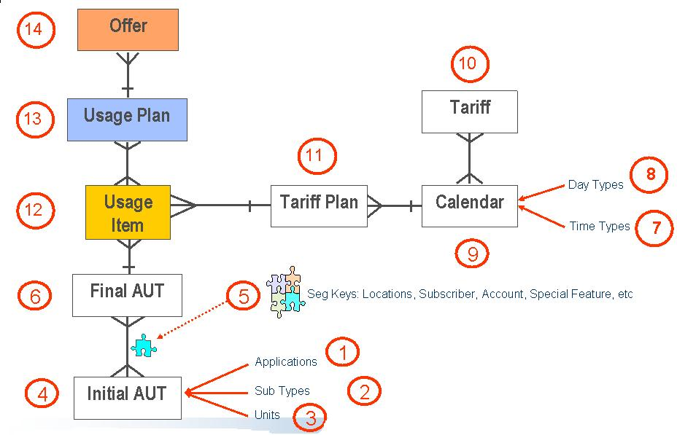

Above are basic configuration works which will be needed as part of mobile postpaid offer configuration. The proposed Comverse ONE RT system will provide rated XDR for all transactions of all mobile postpaid subscribers which are rated and charged in real time. Then VNP BSS may no longer need to have detail product configuration configure in the VNP BSS for mobile postpaid environment. Or it can be reduce to the basic configuration only. This is subject to Elcom/VNP consideration and validation on VNP BSS environment.

The product configuration will need to be configured on both platforms. On Comverse’s PCAT side it will be mainly for real time rating/charging/promotion. For VNP configuration, it will be used mainly for specific task such as time based promotion. The following diagram shows the logical view of new plan configuration.

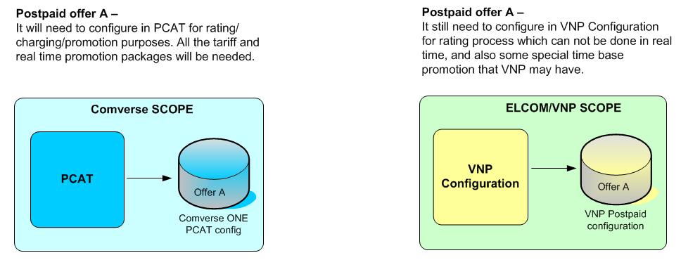

* 1. New subscriber creation

When the new subscribers are needed to VNP’s mobile postpaid network, VNP will need to provision the subscribers in Comverse ONE RT with respective offers/bundle and also on the VNP’s BSS environment. The existing VNP provisioning platform shall integrate to Comverse ONE RT via either SAPI for online provisioning or via CCbatch for offline/batch provisioning. The VNP’s BSS shall able provide the CSR with the set of mobile postpaid offers available on the Comverse ONE RT. The enhancement of the VNP’s BSS shall be under ELCOM/VNP responsibility.

The following diagram shows the high level flow for new subscriber creation. The new subscriber must be provisioned in the Comverse ONE for real time rating/charging/promotion purpose. The new subscriber must be provisioned in the VNP Customer database for subscriber management and specific time based promotion purposes.

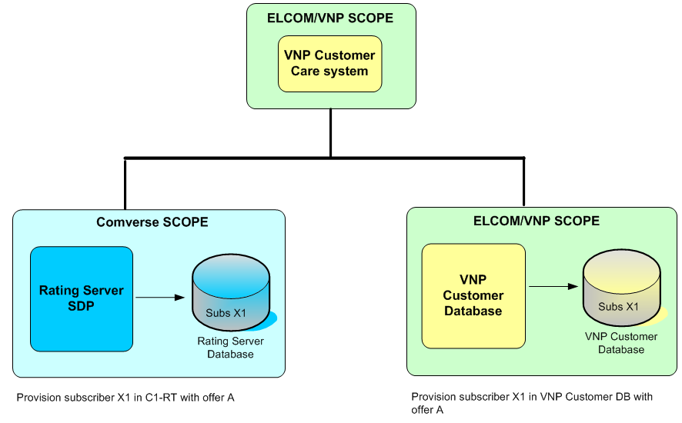

* 1. CDR synchronization

The rated CDR synchronization back to BSS will be handled by ELCOM. Comverse will provide the rated XDR for transactions which are rated and charged in real time. The rating server generates real-time CDRs in the form of an ASCII text file that contains information in addition to that provided in usage files. The name of any billing file has the following format:

IPbill.<cename>.<seq>.<nnnnnnnnnn>

where:

<cename>is the host name of the SLU

<seq>is a 4-digit zero-filled sequence number from 0001 to 9999. The value of the sequence number is stored in the data/cename/IPbillseqfile.

<nnnnnnnnnn>is a 10-digit representation of the coordinated universal time (UTC) in seconds (since 00:00:00 UTC, January 1, 1970. See time (2) when the file is open.

Each CDR file will contain a file header, followed by one or more CDRs. Each CDR has a CDR header.

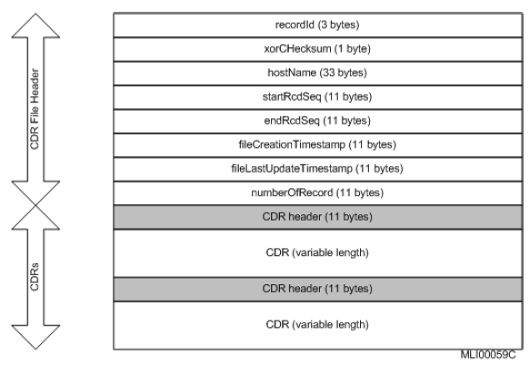

The CDR file has a dynamic set of Balances, Spending Limits, Accumulators and Extension information based on the subscriber’s configuration. The number of fields in a CDR record varies across the same type of activities, depending on the configuration specified in the format file.

Comverse will supply the CDR format specification at later stage to Elcom in order to help Elcom to prepare the proper format translation to fit VNP rated CDR requirements.

The following diagram shows the data flow and responsibility scope of Comverse and Elcom

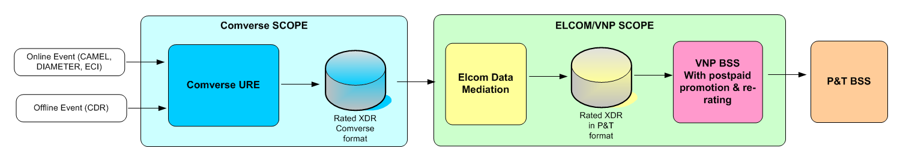

* 1. Adjustment

The payment, adjustment, RC, NRC which may support by existing BSS will need to update to Comverse ONE via the API. For example If Elcom/VNP plans to perform any credit adjustment to the mobile postpaid subscribers for example increase/decrease credit limitation then it can be done via SAPI. The logic and process of this adjustment will belong to VNP’s existing BSS.

Anyway, the credit limits which are kept in the Comverse ONE RT is mainly use for real time credit control only, it does not represent the financial mean of subscriber financial transaction. The existing BSS still host the postpaid subscriber financial transactions via the rated CDR which will be provided by Comverse ONE RT.

The flow shows the basic adjustment function which ELCOM/VNP will need to consider. As use the Comverse ONE as real time credit limit then on case basis customer may ask for special credit limit adjustment which the integration between BSS to Comverse ONE over SAPI may be needed.

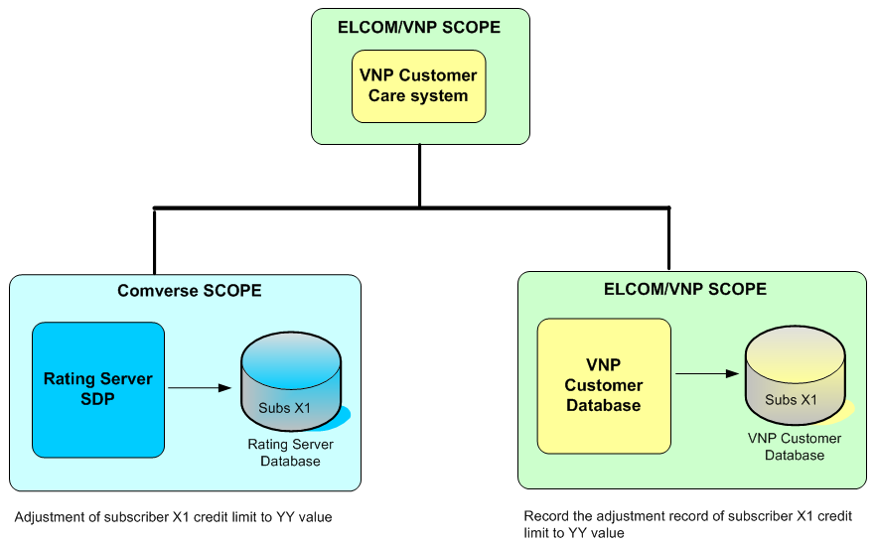

# Integration Points and Description

The following table provides a description of each of the points of integration between the Comverse-supplied components and other systems, 3rd party vendors and network elements belonging to VNP/ELCOM. Within this table, the Interface Owner column identifies the party who has the responsibility for integrating to the other party’s system. Where Comverse is the owner, Comverse will provide the interface and any adaptation of its product to meet the VNP’s specification. Where VNP/ELCOM is the interface owner, Comverse expects CAT/SI to adapt to the Comverse interface, with the support of Comverse personnel where needed.

## Integration Points

The “I/F #” column refers to the interface numbers in Figure 4 on page 10.

| I/F # | Interface | Direction | Type | Interface Owner | Interface Description |
| --- | --- | --- | --- | --- | --- |
| 1 | ECI | Inbound | Online | Comverse | This interface is for real time charging for VNP VAS application. It is based on Comverse Event Charging Interface (IP socket interface). This is the same interface as RTBS payment server interface. |
| 2 | CAMEL-2 | Bi-directional | Online | Comverse | Network interface (CAP2) that will support real time rating 2G/3G voice calls. The CAP2 will also support real time circuit switch video call for 3G subscriber. |
| 3 | CAMEL-3 SMS | Bi-directional | Online | Comverse | Network interface (CAP3-SMS) that will be support rating real time rating for 2G/3G SMS-MO transaction. |
| 4 | MAP | Bi-directional | Online | Comverse | This is the interface that will be used for USSD self care requests such as balance inquiry. |
| 5 | ISUP | Bi-directional | Online | Comverse | Network interface (ISUP) for the IVR pre-call and IVR self-care for real time subscriber |
| 6 | SNMP | Outbound | Online | Comverse | Comverse ONE supports an alarm monitoring interface between Comverse ONE and the Network Management System based on the SNMP V2 protocol. Comverse ONE will proactively alert VNP’s NMC applications of any system alarms through this interface. |
| 7 | Offline CDR | Inbound | Batch | VNP/ ELCOM | CDR from network element for the NE which is not able to support real time or CDR from network which are generated during outage time. The data will be in Comverse Offline URE format |
| 8 | DWH extraction & performance data | Outbound | Batch | Comverse create file | Data warehouse extraction information for VNP DWH purpose. This is the interface that allows external system to retrieve the system performance data and statistics. VNP’s performance team can use this information for detail analysis of the system performance |
| 9 | Unified API (SAPI) | Inbound | Online/ Batch | VNP/ ELCOM | Unified API is the subscriber provisioning/ management API that used to integrate with operator care systems (Customer care, self care, etc...). This interface is mainly focus for U-API integration from VNP’s customer care system. |
| 10 | Unified API (SAPI) | Inbound | Online/ Batch | VNP/ ELCOM | Unified API is the subscriber provisioning/ management API that used to integrate with operator care systems (Customer care, self care, etc...). This interface is mainly focus for U-API integration from VNP’s POS/Dealer application |
| 11 | Unified API (SAPI) | Inbound | Online/ Batch | VNP/ ELCOM | Unified API is the subscriber provisioning/ management API that used to integrate with operator care systems (Customer care, self care, etc...). This interface is mainly focus for U-API integration from VNP’s e-top-up system. |
| 12 | Unified API (SAPI) | Inbound | Online/ Batch | VNP/ ELCOM | Unified API is the subscriber provisioning/ management API that used to integrate with operator care systems (Customer care, self care, etc...). This interface is mainly focus for U-API integration from Comverse provided customer care client |
| 13 | Rated CDR | Outbound | Batch | Comverse create file | The system will generate rated CDR information for post processing by VNP BSS. |
| 14 | SMPP | Outbound | Online | Comverse | This is also the notification interface that will be used to communicate to the customer via SMS. VNP can send SMS to subscribers when certain conditions occur. The criteria of notification will be set via the PCAT. |
| 15 | Unified API (SAPI) | Inbound | Online/ Batch | VNP/ ELCOM | Unified API is the subscriber provisioning/ management API that used to integrate with operator care systems (Customer care, self care, etc...). This interface is mainly focus for U-API integration from VNP’s promotion adjustment system. |
| 16 | Service Order Gateway (SOG) Notification | Outbound | Online | Comverse | This interface will trigger the notification via IP socket information to external service order gateway. This is for fast communication with HLR for real time profile changes. |
| 17 | Diameter | Bi-directional | Online | Comverse | Online charging, as specified in 3GPP and IETF, and is an application of the Diameter Base Protocol (RFC 3588). The application is called Diameter Credit Control (DCC) which will support most VAS/ Content charging requests. It is defined in RFC 4006 and is also known as the Ro Interface. DCC defines a mechanism for a Diameter Client to send real time charging requests to a charging server. |
| 18 | Unified API (SAPI) | Inbound | Online/ Batch | VNP/ ELCOM | Unified API is the subscriber provisioning/ management API that used to integrate with operator care systems (Customer care, self care, etc...). This interface is mainly focus for U-API integration from VNP’s self-care application (web, SMS, and USSD) |
| 19 | Recharge Proxy | Outbound | Online | Comverse | Recharge proxy interface for external recharge voucher server access. Comverse recharge proxy server will communicate to ELCOM’s Recharge proxy gateway via the UDP protocol. The Recharge proxy gateway will communicate to centralize voucher server via the CCWS protocol. |
| 20 | Unified API (SAPI) | Inbound | Online/ Batch | VNP/ ELCOM | Unified API is the subscriber provisioning/ management API that used to integrate with operator care systems (Customer care, self care, etc...). This interface is mainly focus for U-API integration from VNP’s self-care application (web, SMS, and USSD) |

# Technical Architecture

The figure below shows the technical and physical architecture proposed for the Comverse ONE solution for VNP.

## Production system

The figure shows the technical and physical architecture proposed for the Production system of Comverse ONE solution for VNP. The solution consists of hardware components providing real-time and high-availability processing for network interfaces and rating. Please note that the following diagram is mainly provides the concept of system technical architecture. It does not represent the actual number of hardware.

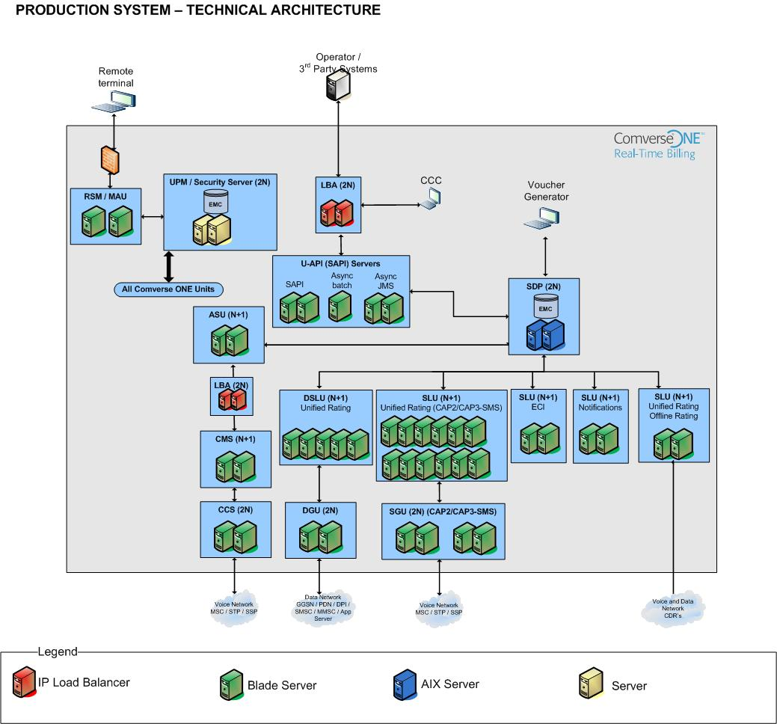

Figure – Technical Architecture for Production system

## Technical Architecture Components

### Online Components

Online components are supplied and supported by Comverse as critical hardware components for online billing operations. The following information is for Production system.

#### Service Data Point (SDP)

Rating Database with Subscribers, Running Balances and Accumulators

* + - Based on Active/Standby cluster of IBM AIX machine with EMC SAN storage

#### Signaling Gateway Unit (SGU)

Provides:

* + - CAMEL Network Interface with CAMEL over HSL-TDM/Signtran.

Redundant Blades per Signaling Gateway Unit for High-Availability

#### Diameter Gateway Unit (SGU)

Provides Diameter Interface for Diameter Charging Interface and Diameter Packet Service

Provides load distribution to SLU rating engines for Diameter protocol interfaces

Redundant Blades per Diameter Gateway Unit for High-Availability

#### Service Logic Unit (SLU)

Provides real time Voice call processing, GPRS Data Sessions, SMS-MO, Diameter, Notifications, Offline Rating, Event Charging Interface

Provides Real-Time Rating, Charging and Promotions with Unified Rating Engine.

N+1 Blades configuration group with SGU/DGU to perform Cluster configuration for High-Availability and scalability

#### Unified API Servers

Provides single unified API to access Comverse ONE business logic and data

Unified API server clusters typically arranged as separate clusters to perform dedicated functions:

* + - ASynch – used to implement the Unified API asynchronous interface. Used for post-recharge Offer swap, running campaigns.
    - SAPI
    - Async JMS

#### Application Server Unit (ASU)

Provides Service Execution Environment for IVR Self-Service Applications

N+1 Blade Configuration with HW Load-Balancers for High-Availability

#### Comverse Media Server (CMS)

Provides High Density Intelligent Peripheral (IP) Unit for IVR Applications

N+1 Blade Configuration for High-Availability

8 E1/T1 Lines per Network Interface Module (NIM2) per CMS

IVR Capacity of 192 (T1) or 240 (E1) Voice Channels per NIM2

#### Call Control Server (CCS)

Provides ISUP Network Interface for wit Intelligent Peripheral (IP) Unit for IVR Applications h Low-Speed Links (E1/T1 Links).

Redundant Blade per Call Control Server for High-Availability

Redundant Signaling Link Modules (SLM) per Call Control Server

Signaling Capacity of 16 Signaling Links per Call Control Server

#### Unified Platform Manager (UPM) and Security Server

Provides:

* + - Centralized System Management with Operators NOC Interface
    - Centralized Security Server with Authentication/Authorization/Accounting

Redundant rack mount server for High-Availability

#### Remote Service Monitoring and Maintenance Access Unit (RSM/MAU)

Provides remote access to the Comverse ONE system for maintenance and support

Redundant Blade

#### Load Balancing Agent (LBA)

LBA provide load balancing between external clients and:

* + - Event Charging and OSA SLU clusters
    - Unified API clusters

### Hardware Scalability and High Availability

Comverse ONE provides both vertical and horizontal scalability.

Vertical scalability is achieved by using larger and more powerful hardware configurations. Most Comverse ONE components are vertically scalable.

Horizontal scalability is achieved by using multiple identical hardware components. Most Comverse ONE application server components are horizontally scalable.

All Comverse ONE components are highly available. HA is achieved via 1+1 (2N) or N+ 1 configuration.

The following diagram illustrates the scalability and high availability scheme for each of the hardware components.

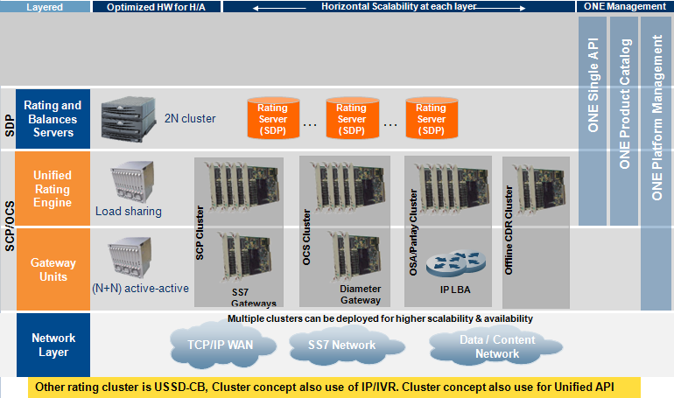







**END OF DOCUMENT**

# About Comverse

Comverse is the world’s leading provider of software and systems enabling value-added services for voice, messaging, mobile Internet and mobile advertising; converged billing and active customer management; and IP communications. Comverse’s extensive customer base spans more than 130 countries and covers over 500 communication service providers serving more than two billion subscribers. The company’s innovative product portfolio enables communication service providers to unleash the value of the network for their customers by making their networks smarter.

For more information on our products and services, visit our website at: [www.comverse.com](http://www.comverse.com/) or contact us at: [information@comverse.com](mailto:information@comverse.com)

100 Quannapowitt Parkway Wakefield, MA 01880 USA

Tel: +1.781.246 9000  
Fax: +1.781.224.8143